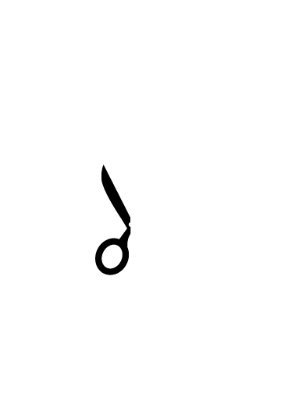
Trim along dotted line

Brandon & Jessica Folsom
September 9th, 2010

Font used in example is Adobe Garamond 22 point Regular and 16 point Italic.

