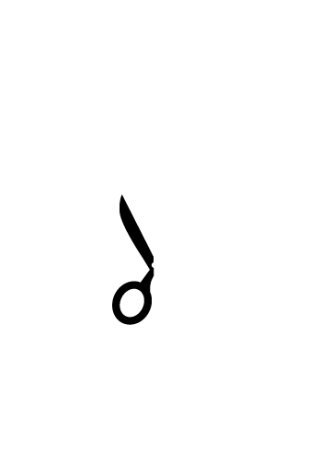
Trim along dotted line

Jacob & Kristina Waverly
June 9th, 2010
Font used in example is Gill Sans 22 point Regular and 15 point italic.

